Step 1 - Go to <https://aws.amazon.com>

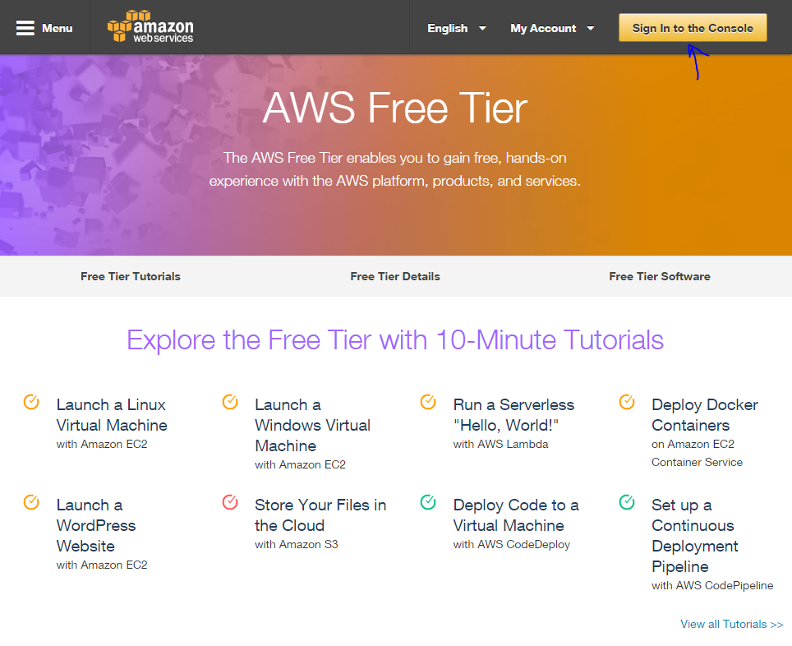

Step 2 - Log in

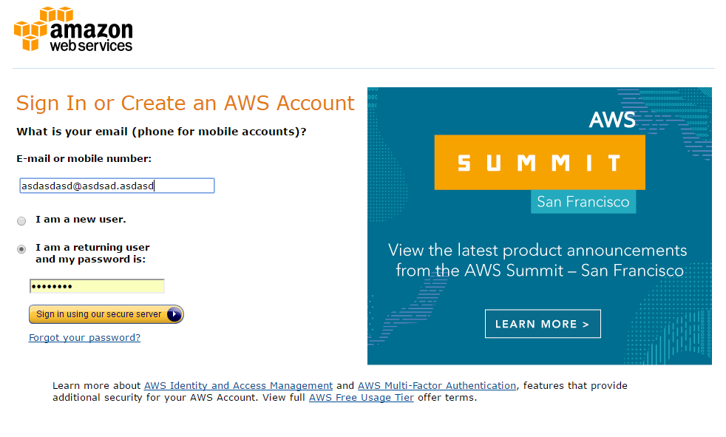

Step 3 - See AWS dashboard

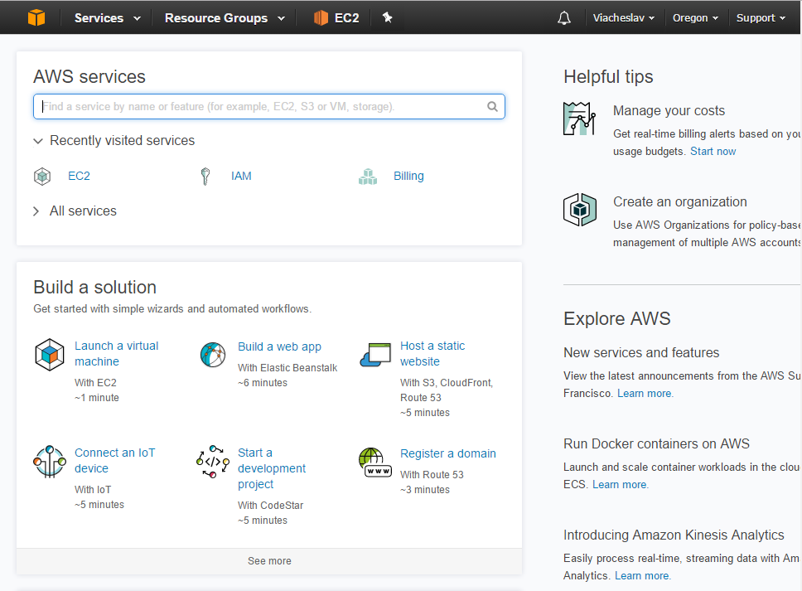

Step 4 - Go to EC2 page

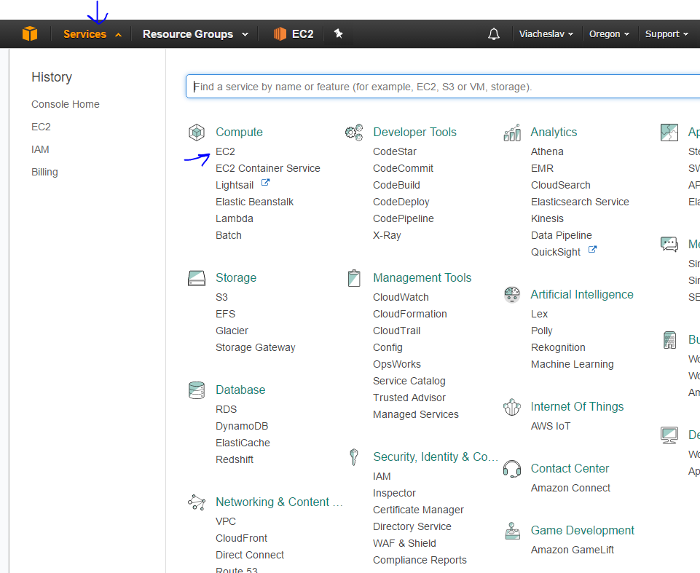

Step 5 - See Instances dashboard

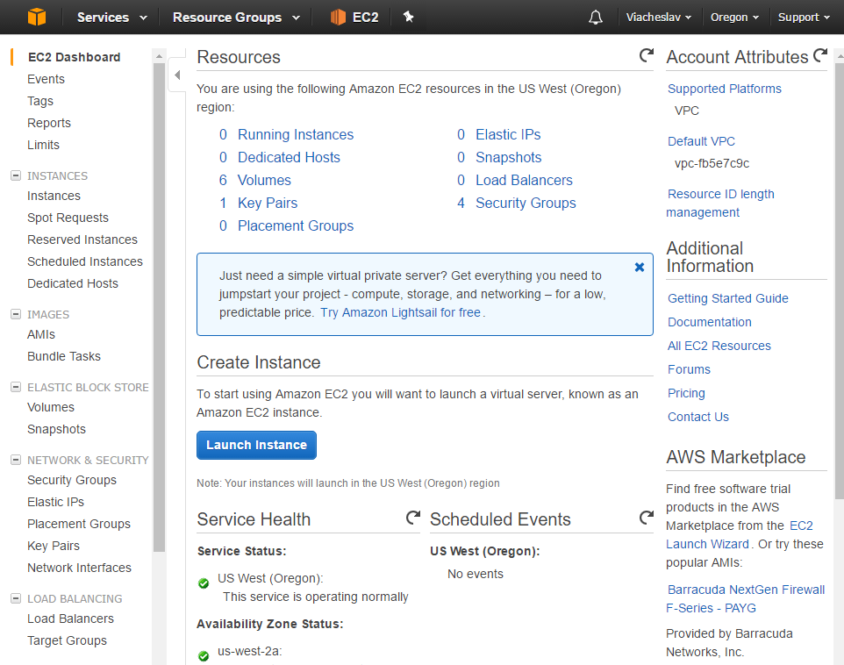

Step 6 - Open Instances tab 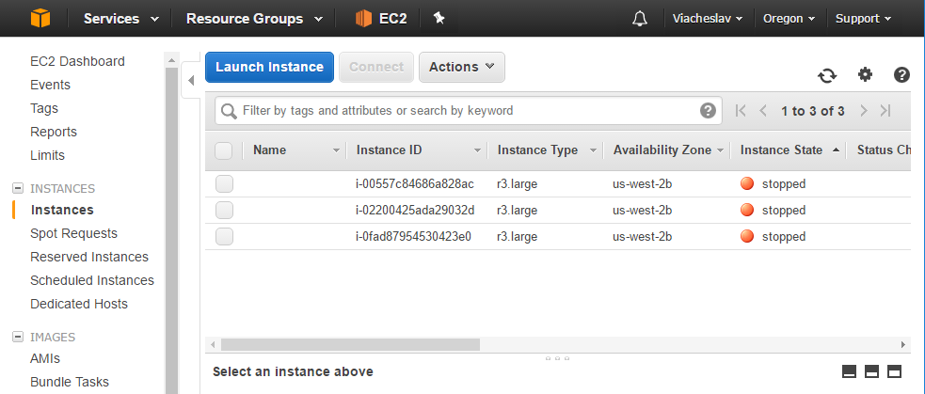

Step 7 - Press Launch Instances button to add new instance

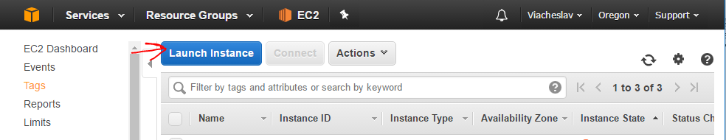

Step 8 - See Choose OS image page

Step 9 - Go to Community AMIs tab and search for ami-0a559a73

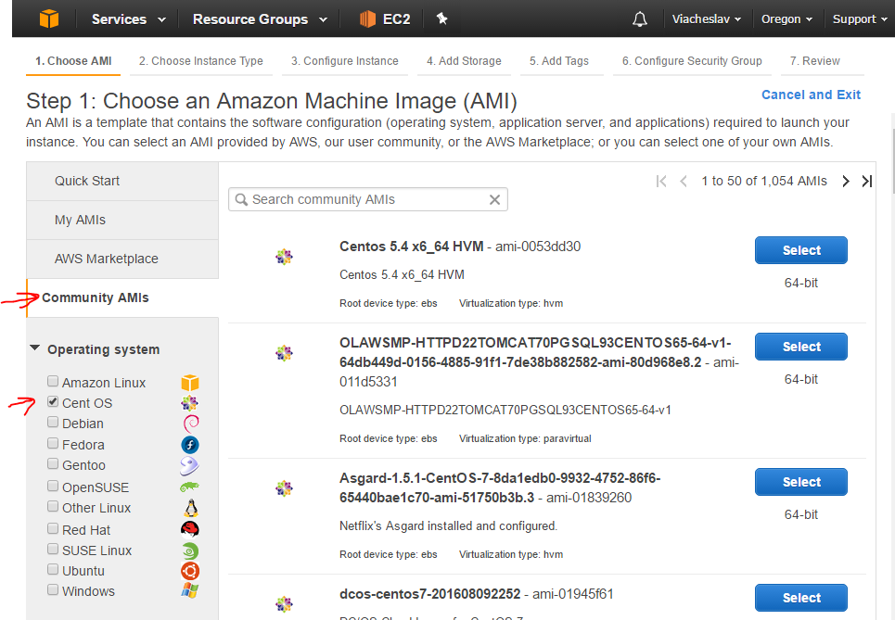

Step 10 - Than find “ami-0a559a73” and press Select

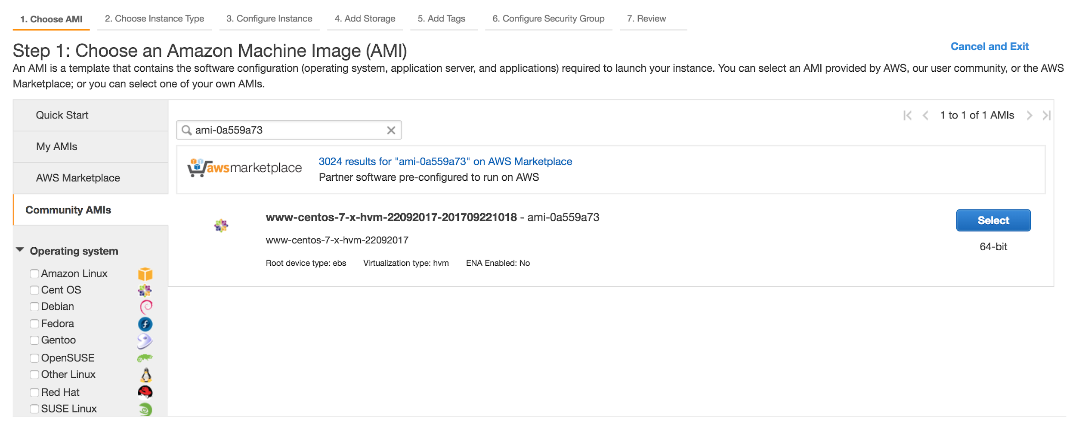

Step 11 - See Choose instance type page

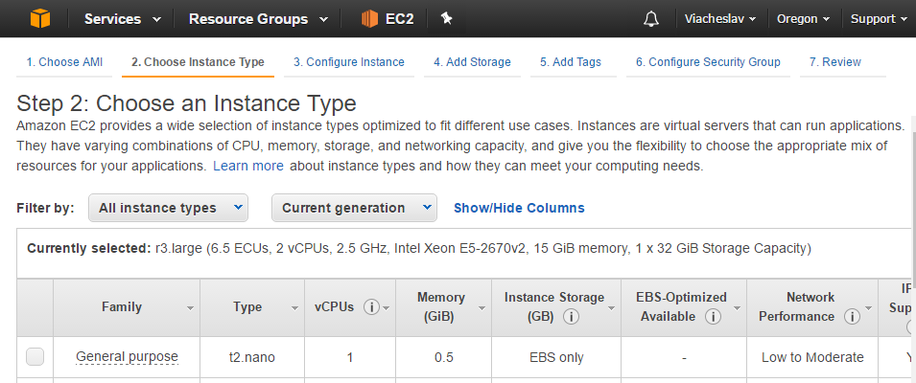

Step 12 - Choose “c4.large” type (2 CPU, 3.75 GB RAM) and go to “Next: Configure instance details”

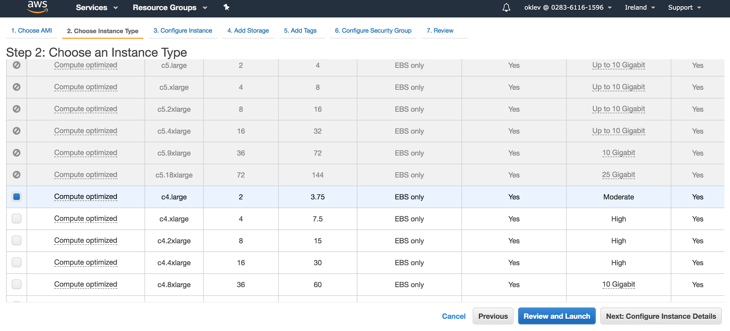

Step 13 - Go to “3. Configure Instance” tab

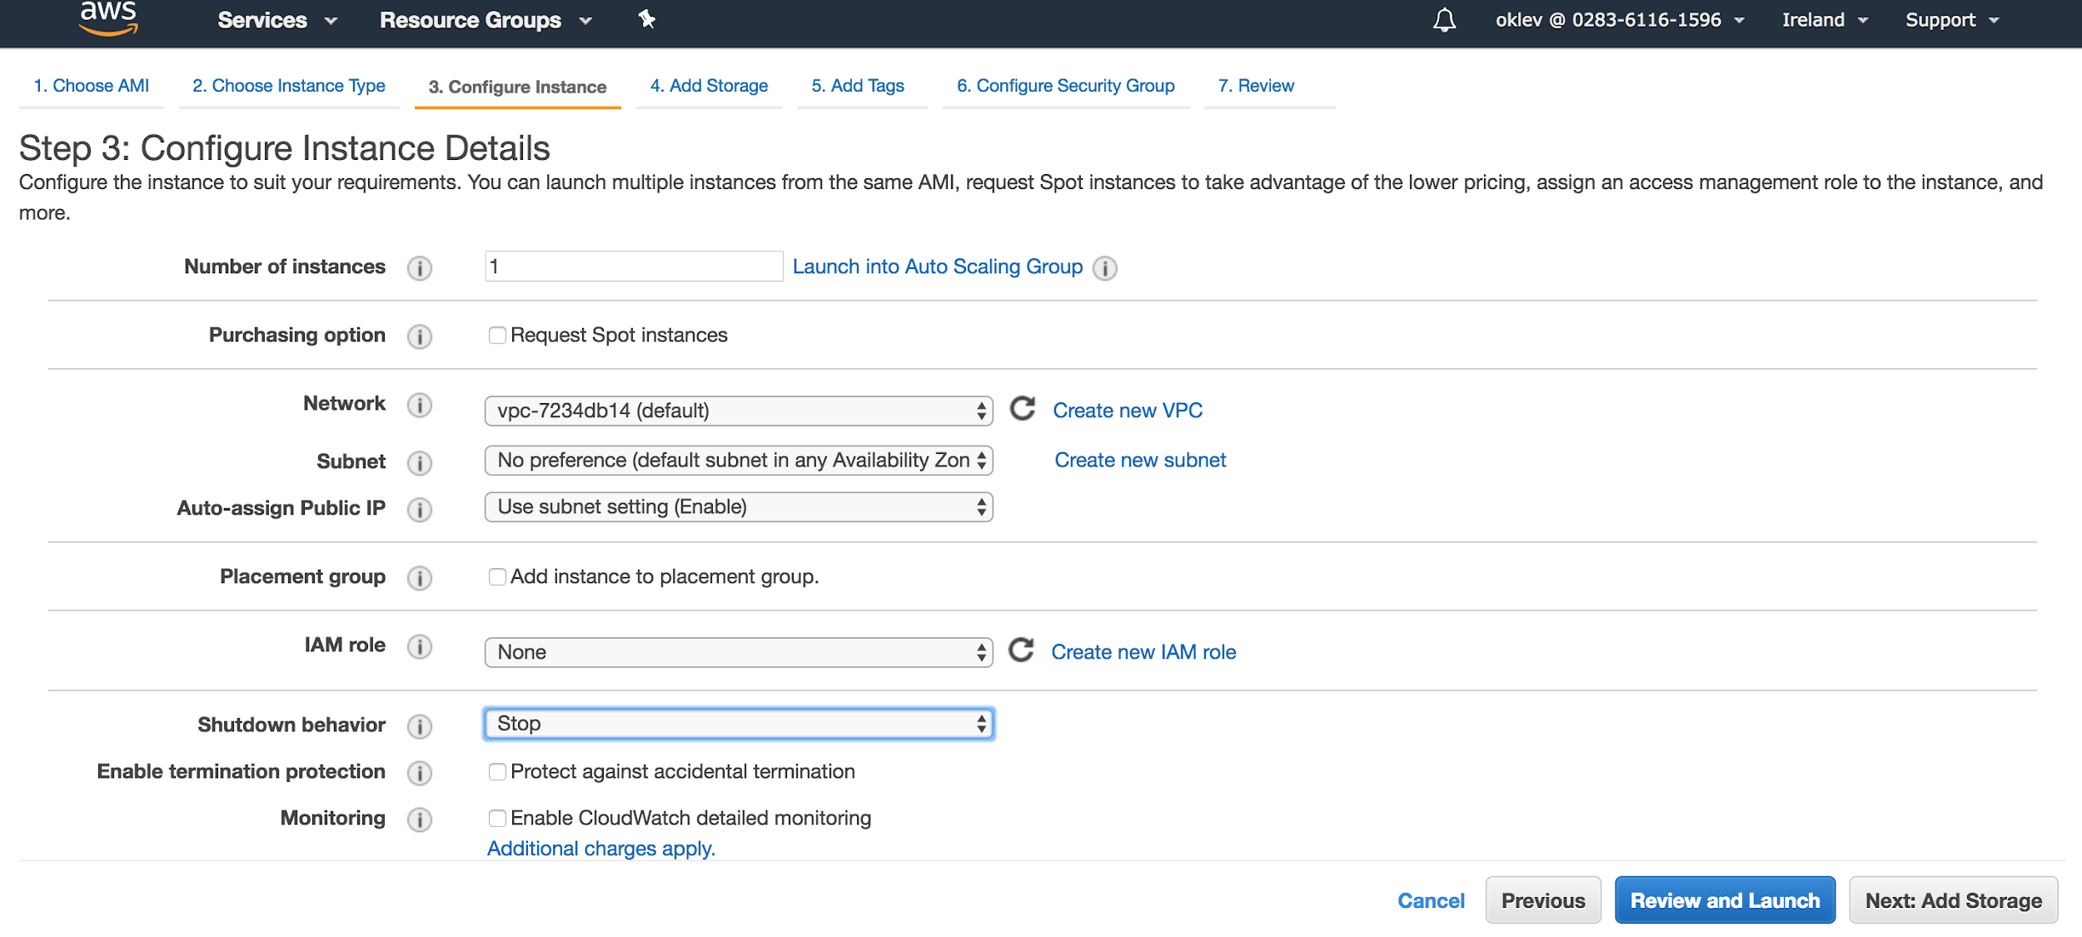

Step 14 - Go to “Next: Add storage” tab. Set 8 (GiB) in Size input.

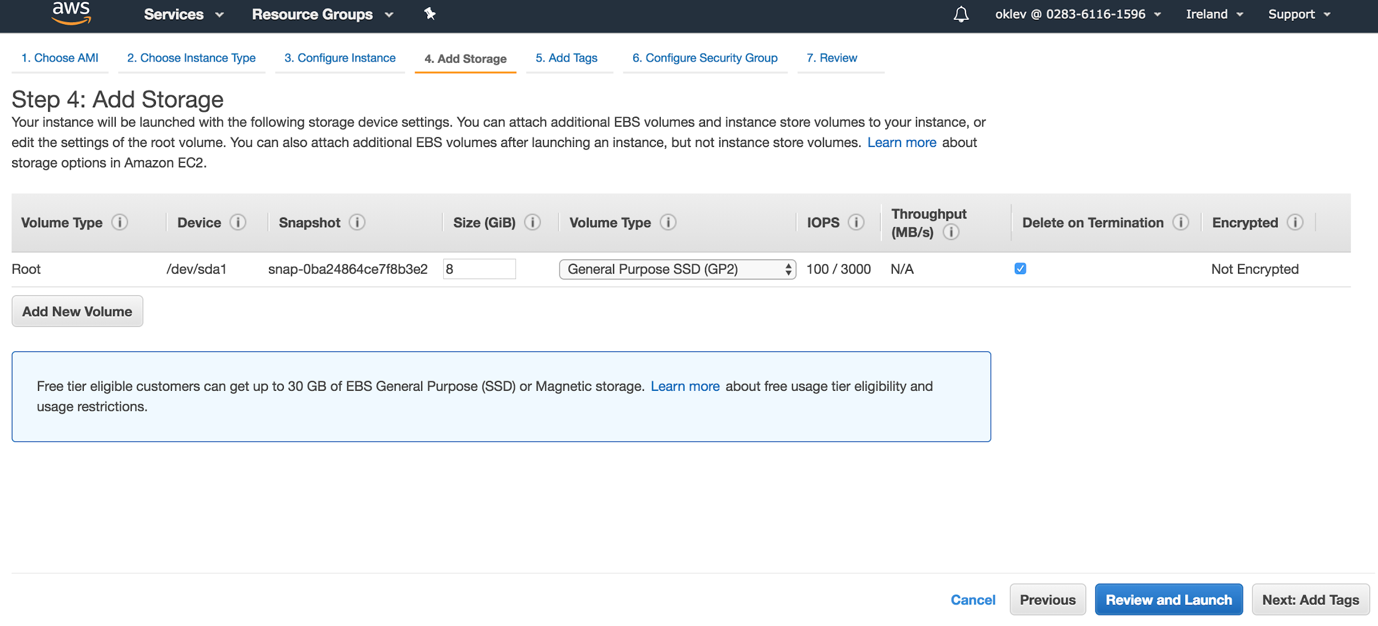

Step 15 - Add some tags if any

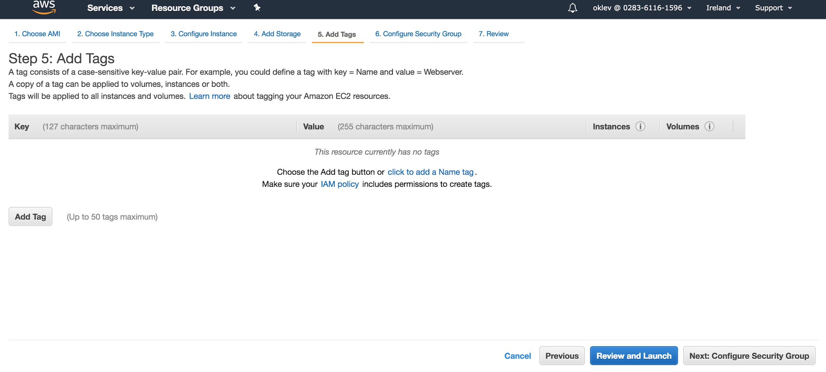Step 16 - For test purposes, open Instances for all connections from your IP. Do NOT do this on production. To do this – go to Configure Security Group tab and add rule.

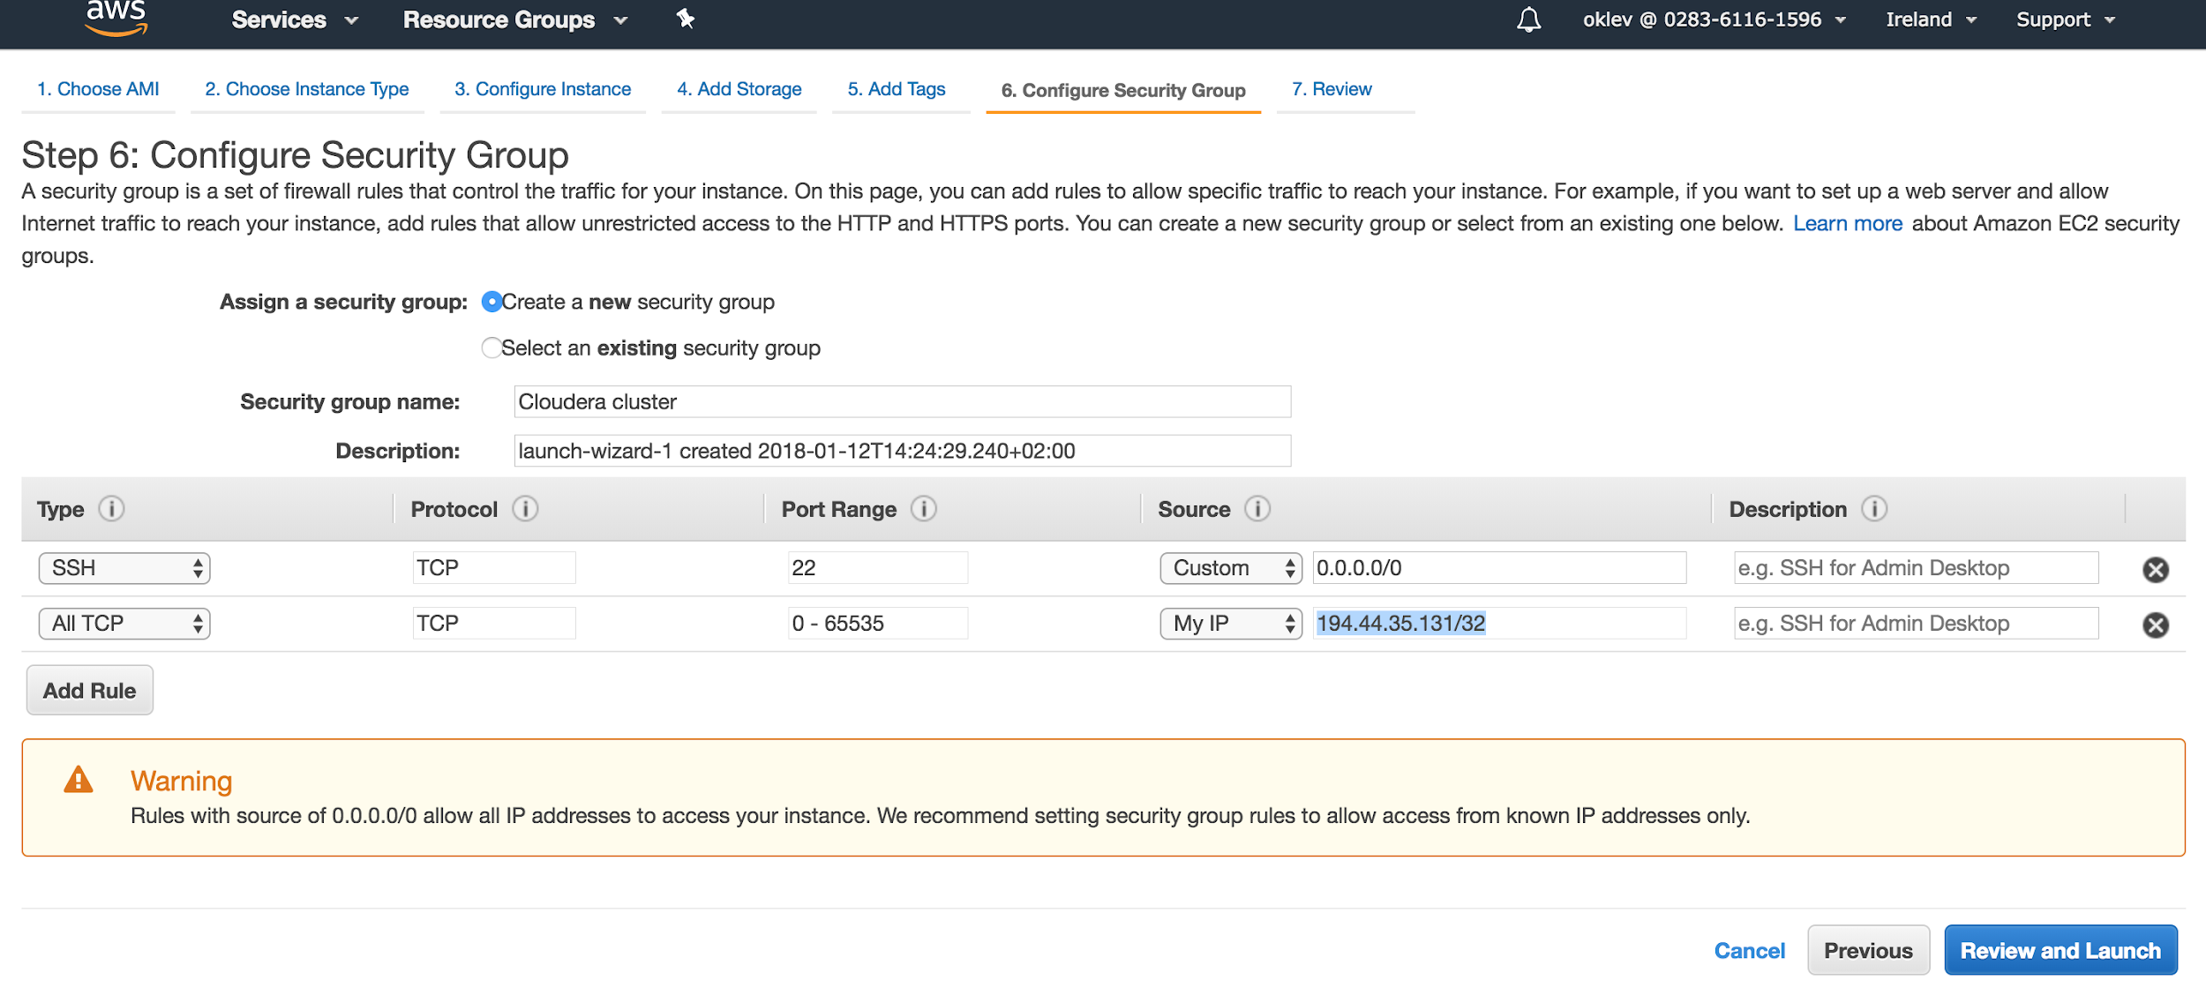Step 17 - Press Review and Launch button. You will see Review page with warnings – it is OK. Press Launch

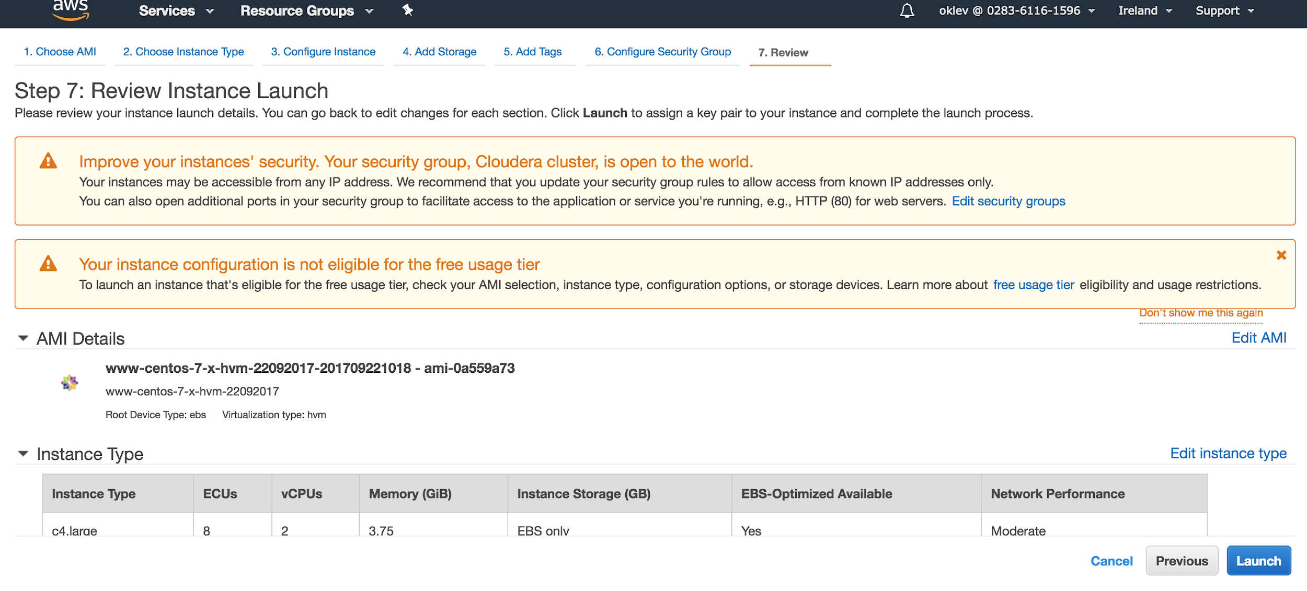

Step 18 - You will see “Select an existing key pair or create a new key pair” (SSH key). Choose Create a new key pair in dropdown. Type (any, better Latin) name. Press Download Key Pair. You will use SSH key further in this instruction, to connect instances and set-up Instances OS.

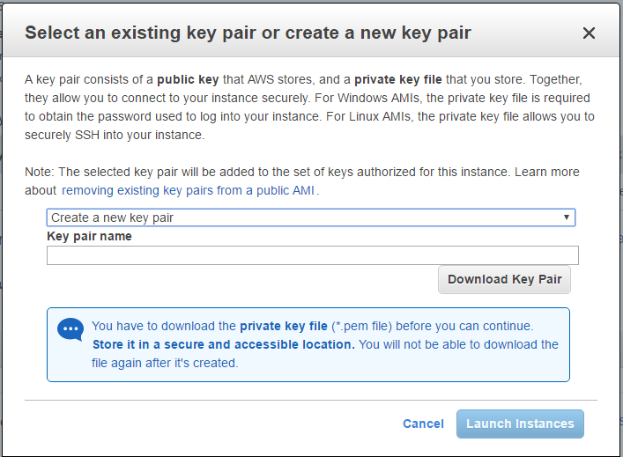

You will download pem-file. Remember where you save it.

Press Launch Instances button

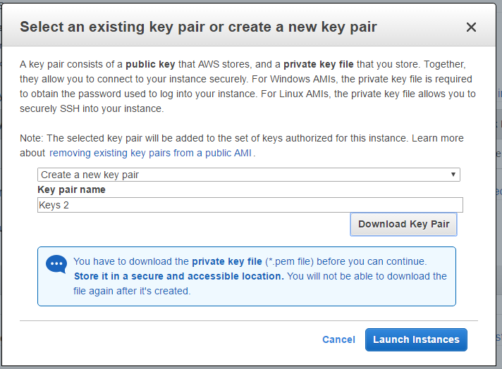

You will see success page

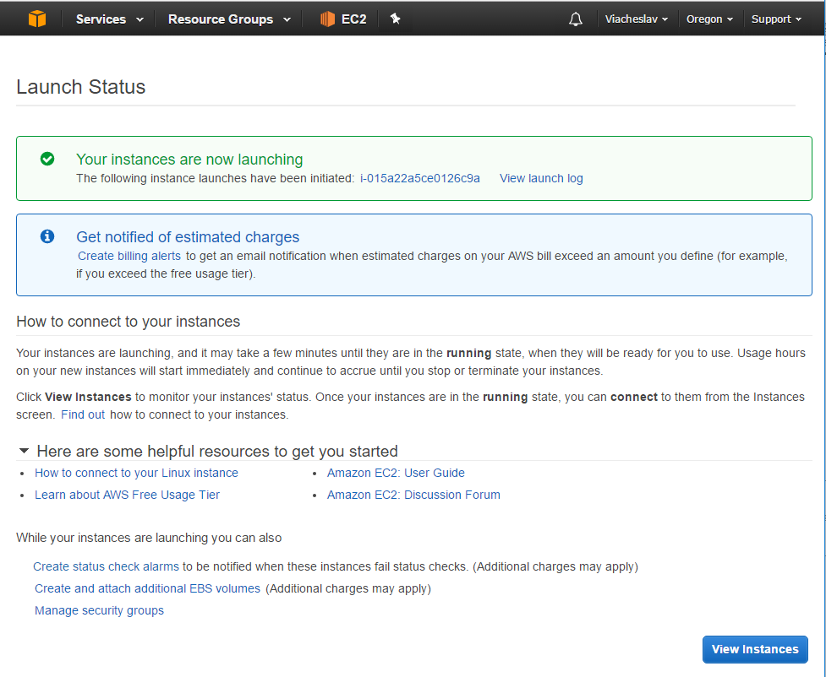

Press View Instances.

You should see 1 new running Instances. (It can be in progress for a while – it`s OK).

